Data Repository Access [tested on December 23, 2024]

DUOS can be accessed using any Google or Microsoft account. First open to the DUOS website at <https://duos.broadinstitute.org/> . On the home page, click on the **Sign In** button.

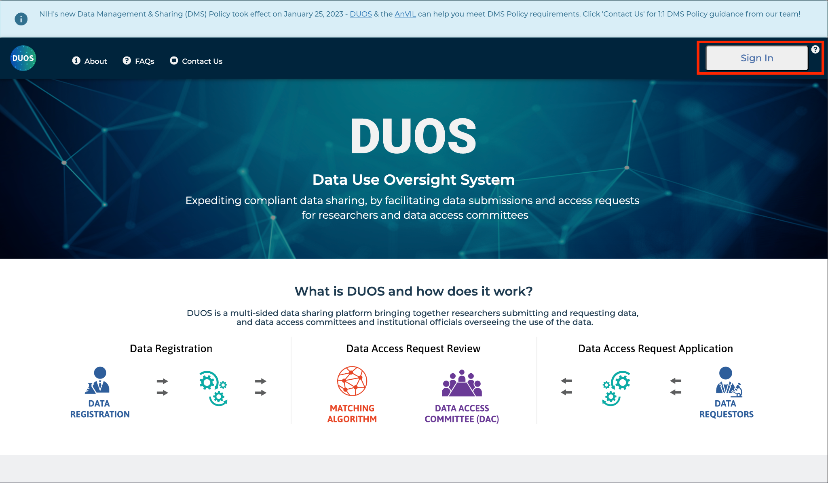

In this example, we use a Google account, and therefore we select **Sign in with Google**. To sign in with a Microsoft account, we would have used **Sign in with Microsoft.**

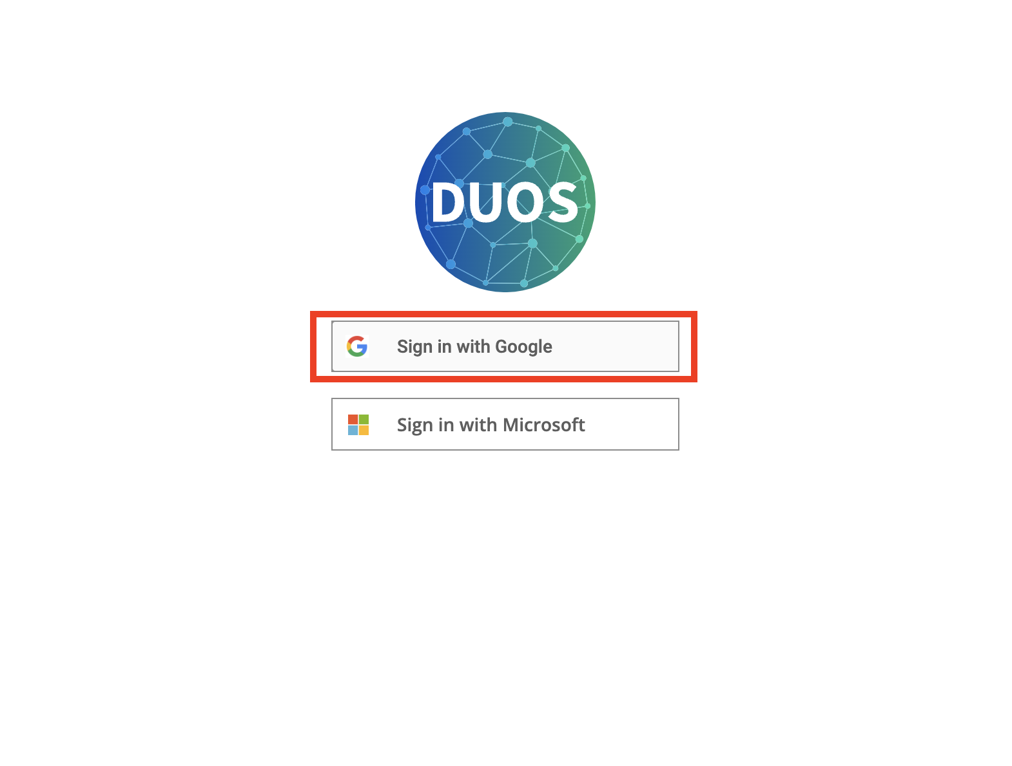

The prompt now asks us to enter our Gmail address and sign in.

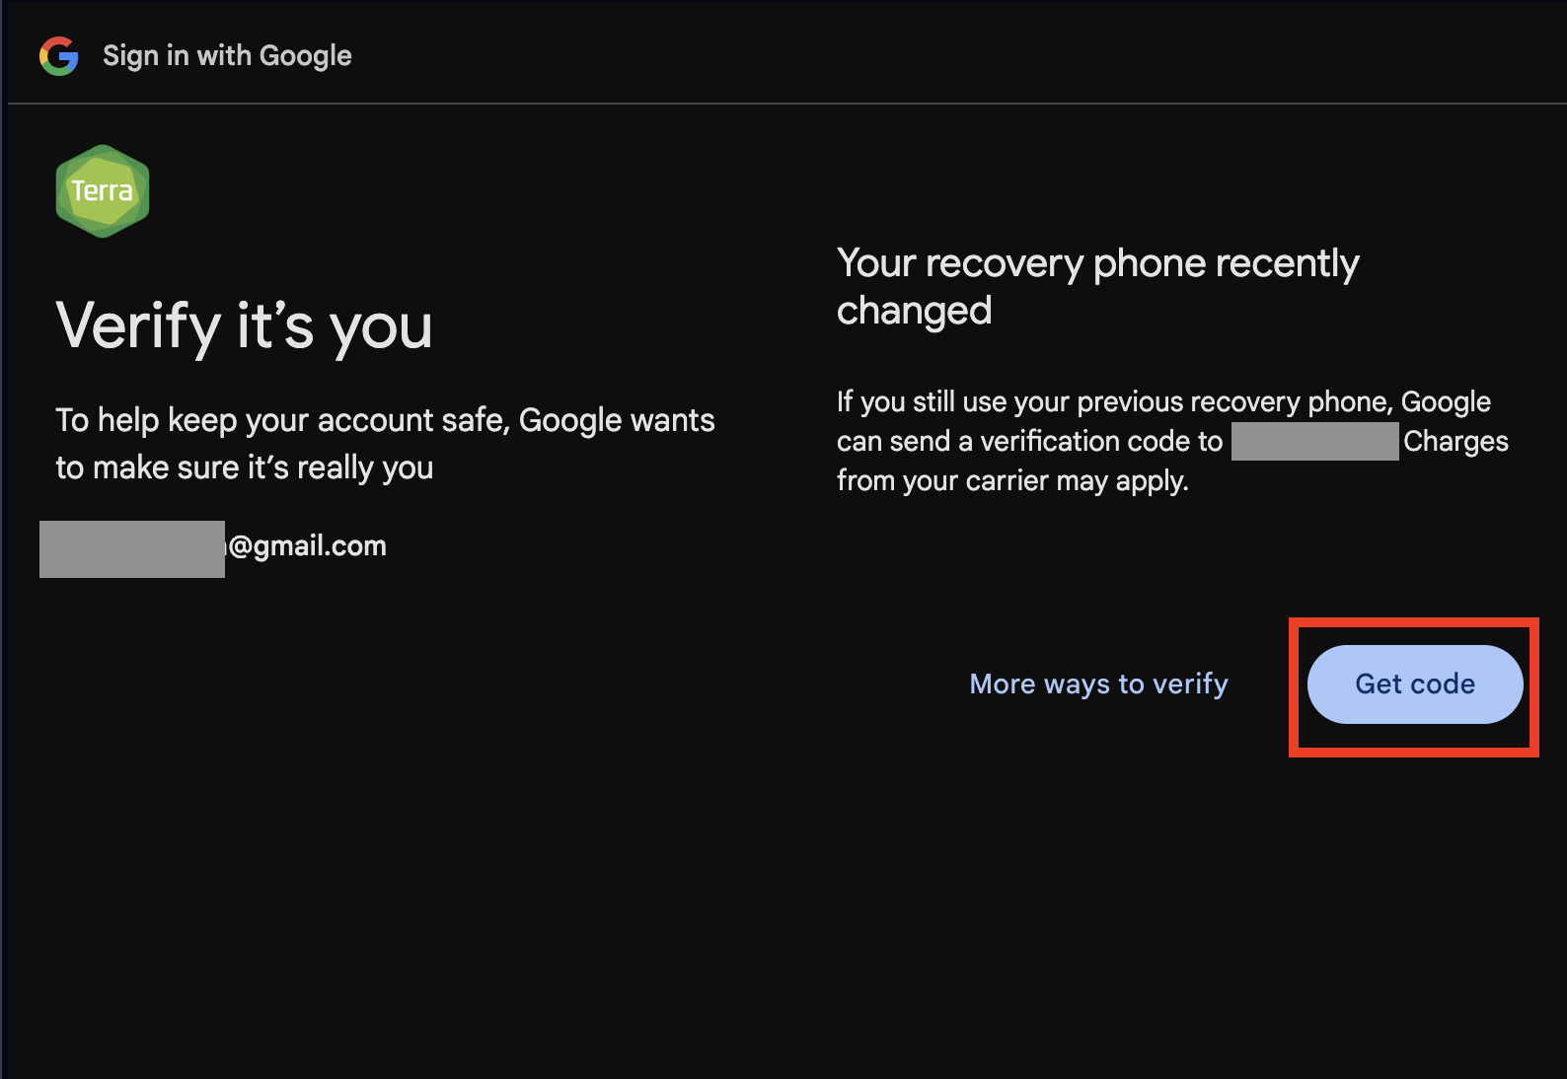

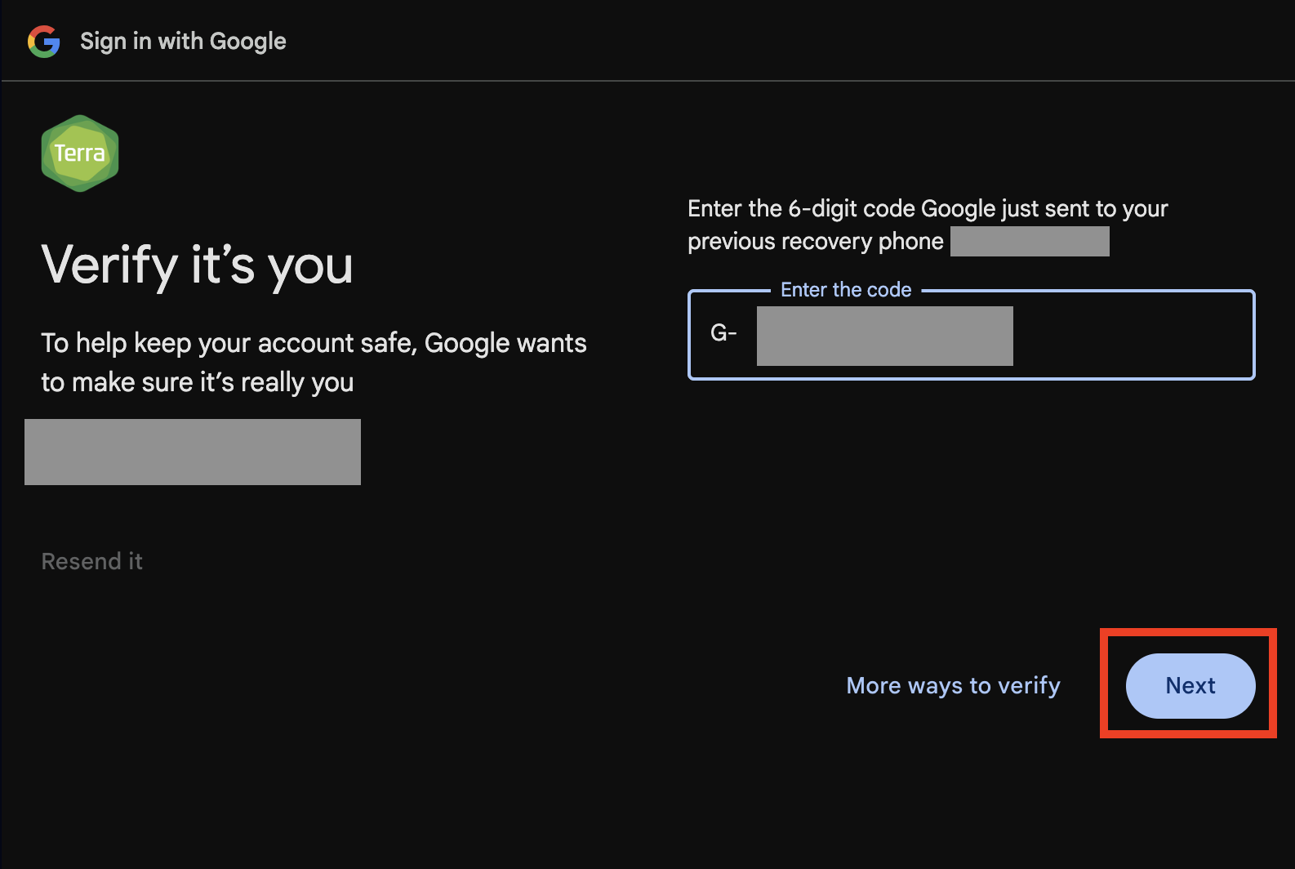

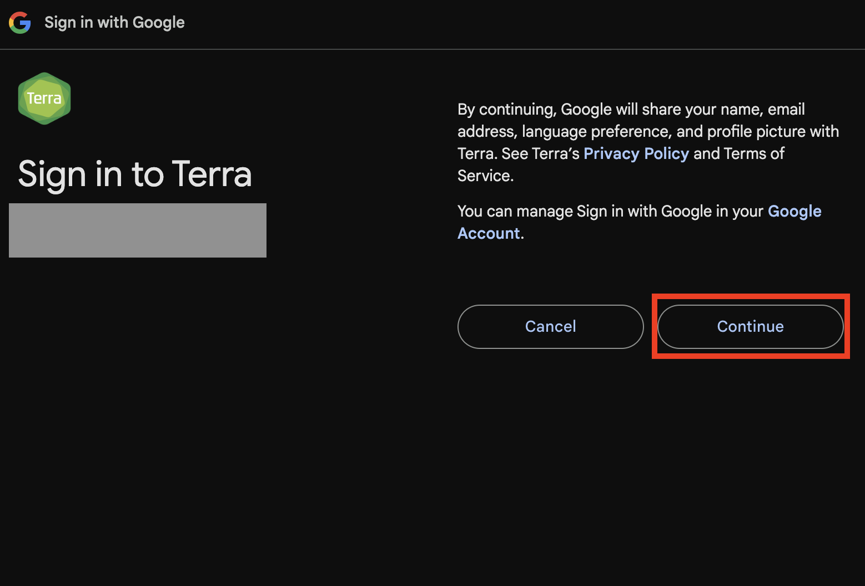

In the next screen, we have to review the terms of service.

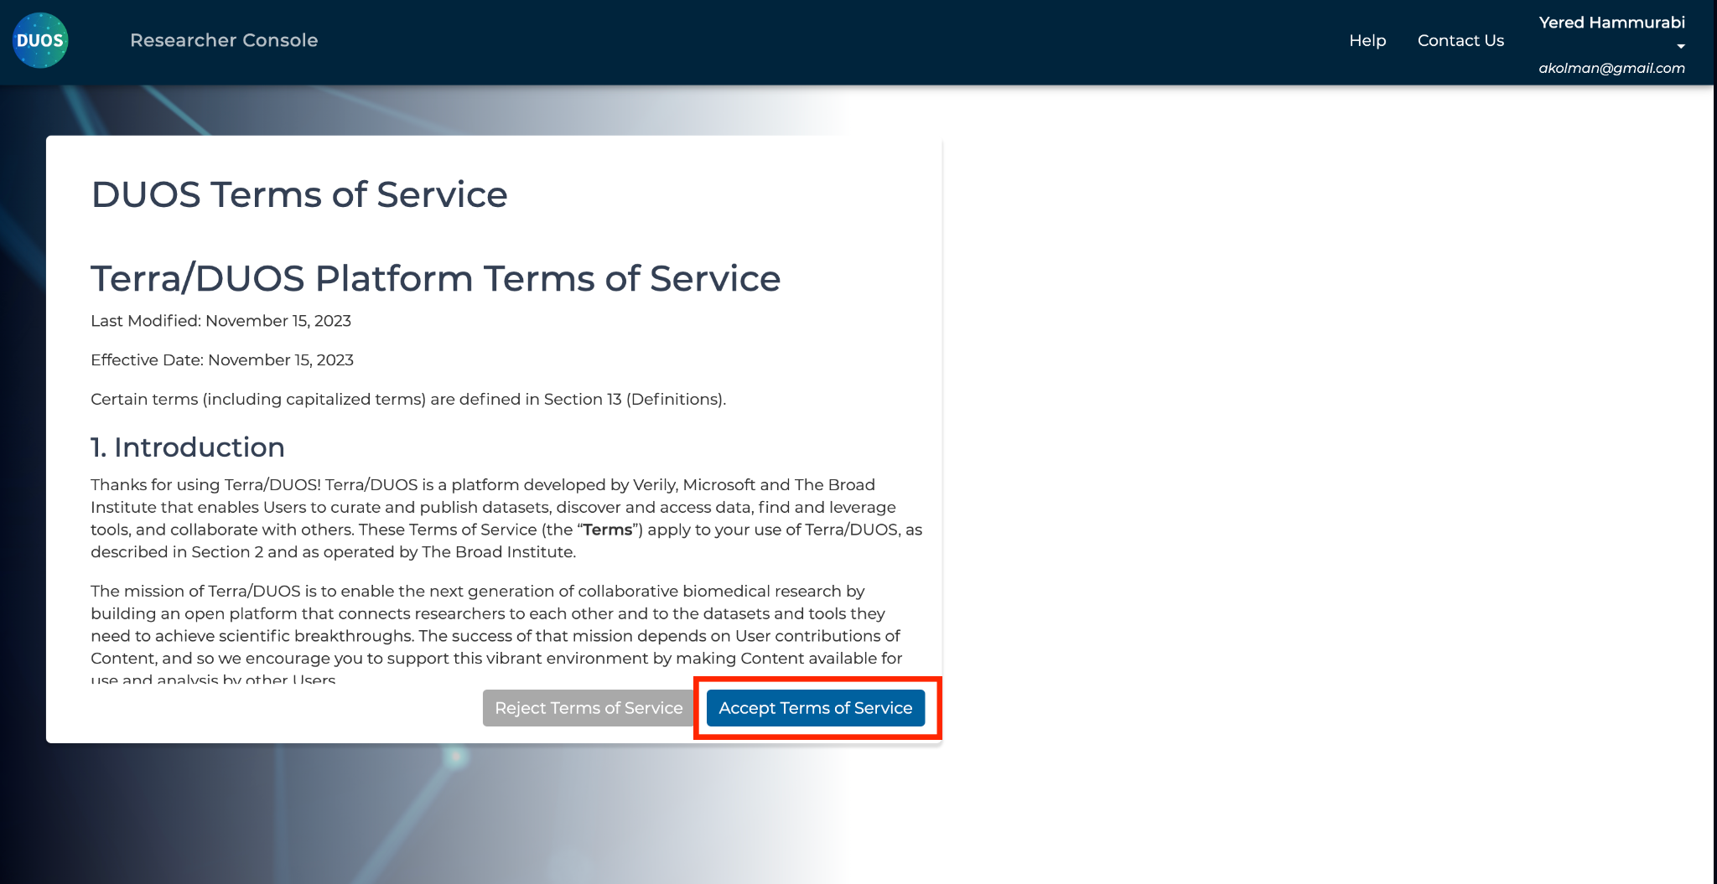

In the next screen, we enter the details of our profile and review the terms of service.

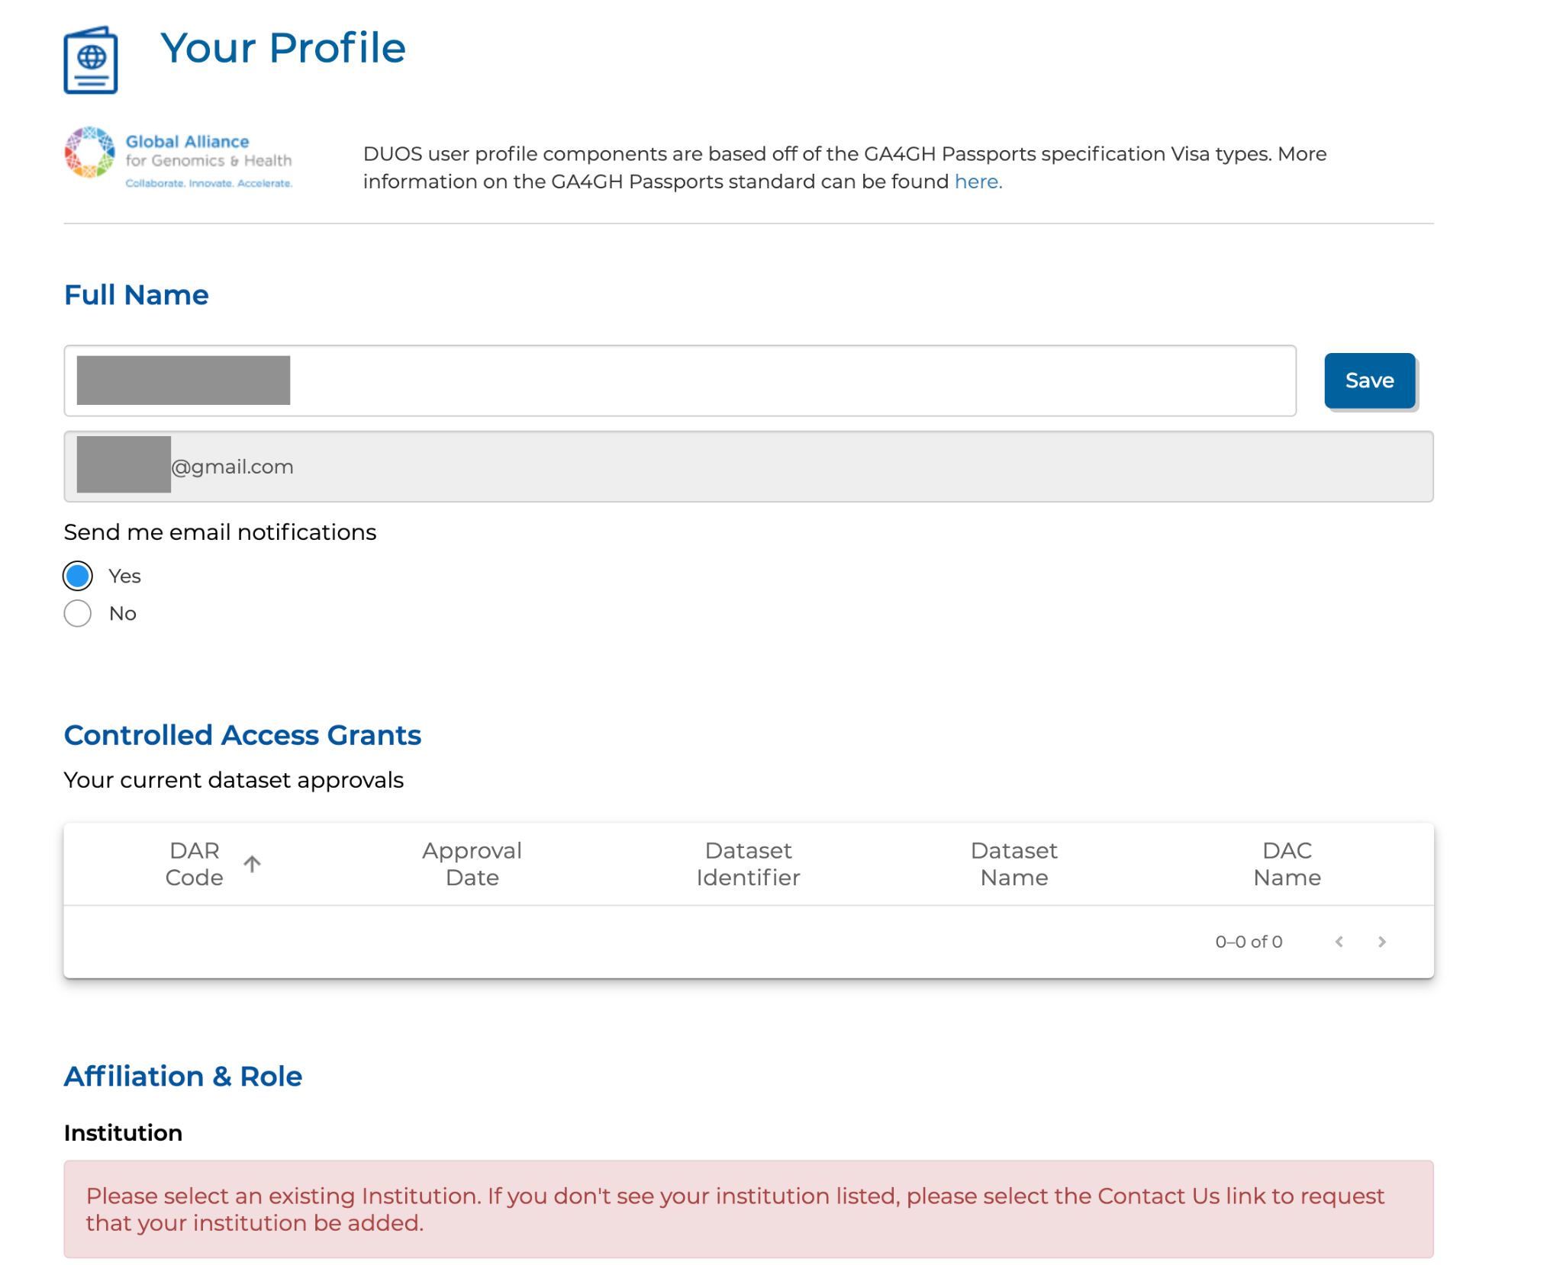

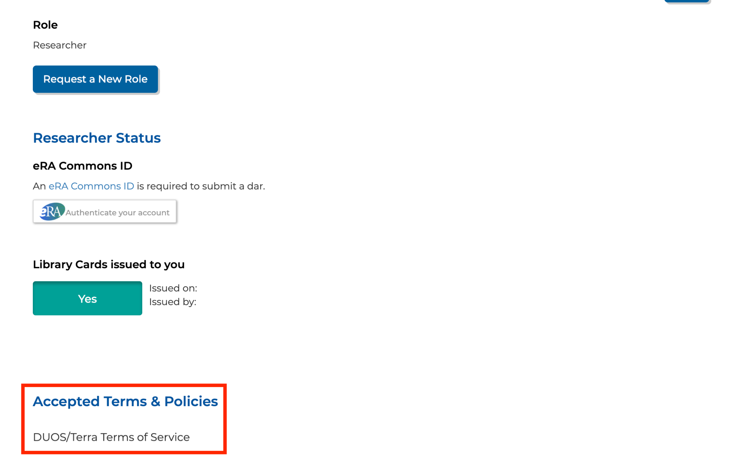

For more details, see: <https://support.terra.bio/hc/en-us/articles/28504837523995-How-to-Register-for-DUOS>

Once you have registered for DUOS, you can look up the raw sequencing data in the **DUOS Data Library.** The keyword **covid-19** will show the full COVID-19 Autopsy Tissue data set. This data set is the original submission from [1](https://paperpile.com/c/nCh2O4/7g2c).

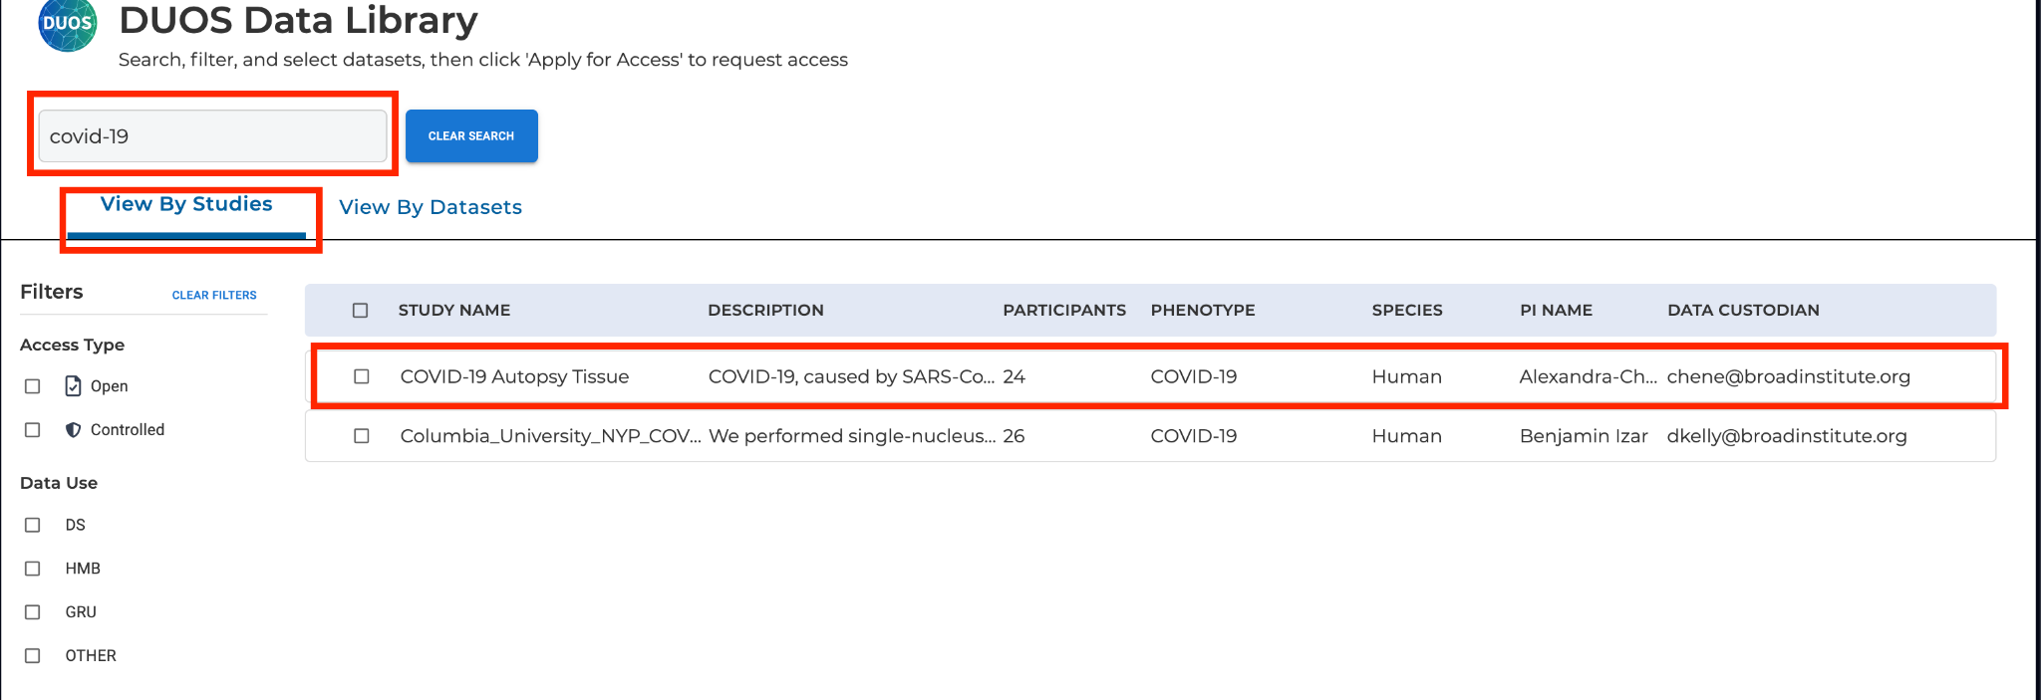

The data sets for this paper (DUOS-000126 and DUOS-000127) can be accessed by clicking on the **View by Datasets** tab.

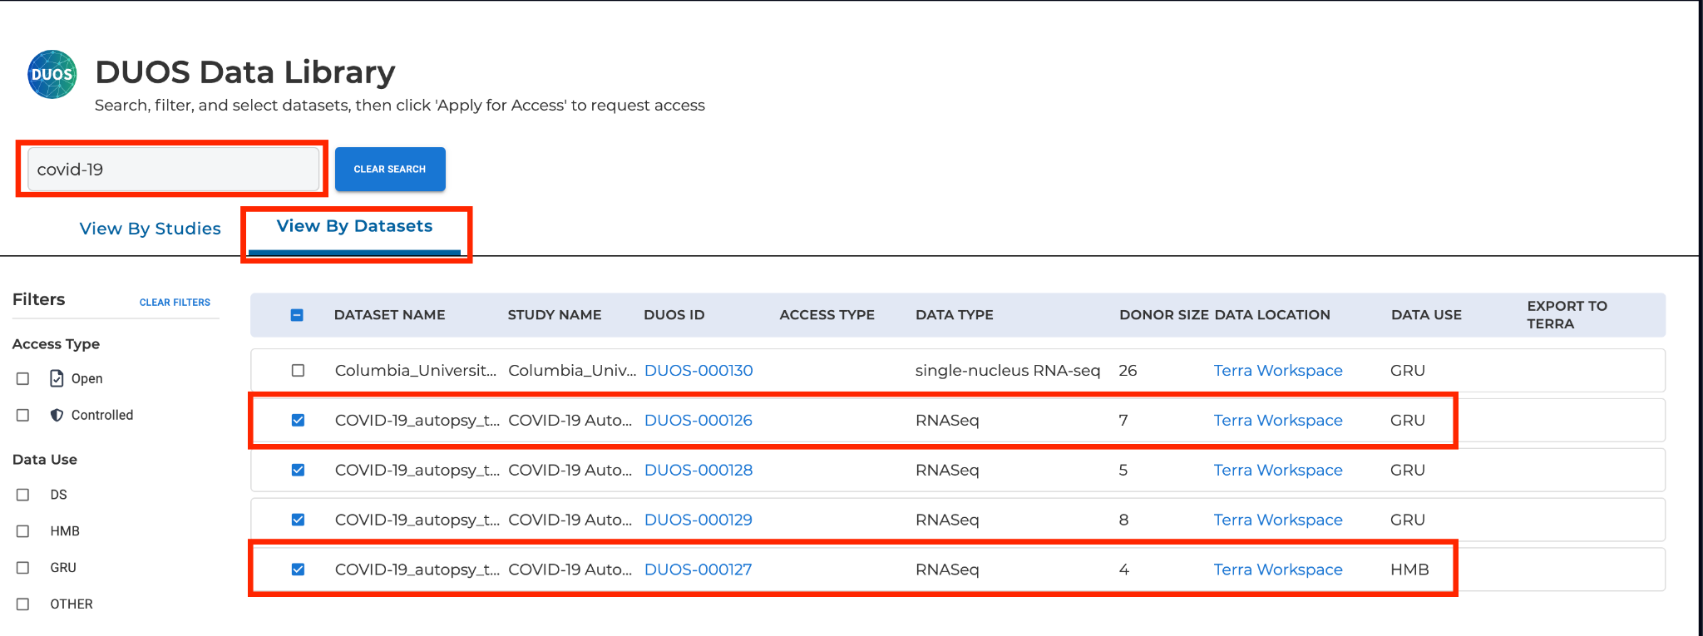

The raw sequencing data are under controlled access. Therefore, one must submit a **DAR (Data Access Request)** in order to access them. For more details, please refer to: <https://support.terra.bio/hc/en-us/articles/28510945983003-How-to-Submit-a-Data-Access-Request-DAR-in-DUOS>

Alternatively, the data set can be exported to **Terra** ( <https://app.terra.bio/> ) for direct analysis there. **Terra** is a scalable, secure research platform, jointly developed by the Broad Institute of MIT and Harvard, Microsoft, and Verily, to help biomedical researchers to access data, run analysis tools, and collaborate. For more details, see:

<https://support.terra.bio/hc/en-us/articles/31034718333851-How-to-access-and-export-controlled-data-to-Terra-via-DUOS>

**References**

1. [Delorey, T. M. *et al.* COVID-19 tissue atlases reveal SARS-CoV-2 pathology and cellular targets. *Nature* **595**, 107–113 (2021).](http://paperpile.com/b/nCh2O4/7g2c)